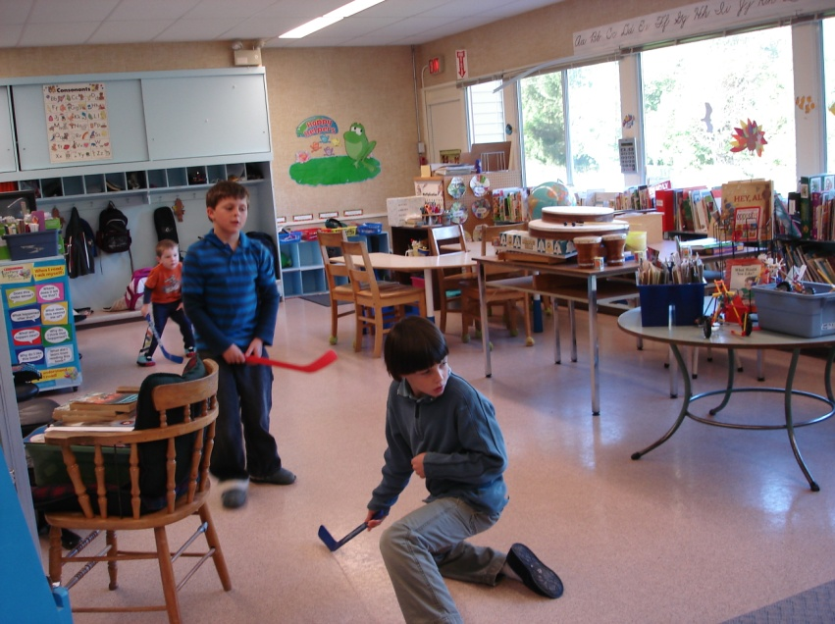
January 10-13: Monday to Thursday
January 17-20: Monday to Thursday
Happy New Year!

Well, here we are. It’s a brand new year. We hope that all of you had as much fun over the holidays as we did. Family, friends and lots of joy filled the air as we celebrated the season.

This week we have started our unit on Sound and have been having great fun experimenting with many different ways to create it. All of the kids made their own Pan Flute. They really enjoyed it.

We will travel to Victoria starting next Tuesday for Gymnastics and other exciting activities. This will happen every Tuesday until March 1st.

Athena George will be coming to our school to give us a presentation on seals.

Today we enjoyed time at the beach for the first time in quite a while.

